**The Bias and Variance Dilemma in Machine Learning: A Comprehensive Case Study**

**Abstract:** This case study delves into the intricate relationship between bias and variance in the context of machine learning. Through an in-depth exploration of the bias-variance trade-off, we examine the practical implications of these concepts in the real world. We present a detailed analysis of a machine learning problem, highlighting the challenges associated with bias and variance, and discuss strategies to strike a balance between them. This case study offers a valuable insight into the bias-variance dilemma, a fundamental aspect of model performance optimization.

1. **Introduction**

The Bias-Variance Dilemma is a fundamental concept in machine learning that impacts the performance of predictive models. Striking the right balance between bias and variance is crucial for building models that generalize well to unseen data. In this case study, we will explore the Bias-Variance Dilemma through a detailed analysis of a machine learning problem. We will cover various aspects related to bias and variance, their effects on model performance, and strategies to mitigate these issues.

1. **Understanding Bias and Variance**

**2.1 Bias**

Bias refers to the error introduced by approximating a real-world problem, which may be complex, by a simplified model. A high bias model underfits the data, meaning it is too simplistic to capture the underlying patterns. This results in poor model performance, as it fails to generalize from the training data to unseen data.

**2.2 Variance**

Variance, on the other hand, represents the model's sensitivity to fluctuations in the training data. A high variance model overfits the data, meaning it is too complex and fits the training data's noise, rather than the underlying patterns. While high variance models may perform well on the training data, they typically perform poorly on unseen data.

1. **Bias and Variance Trade-off**

The Bias-Variance Trade-off is the delicate balance between bias and variance when building machine learning models. Achieving the right balance is essential for creating models that generalize well to new, unseen data. In this section, we will delve into the trade-off and how it influences model performance.

To understand the Bias-Variance Trade-off, we can envision a curve where bias and variance are inversely related. As one increases, the other decreases, and vice versa. The goal is to find the optimal point on this curve that minimizes the model's overall error on unseen data.

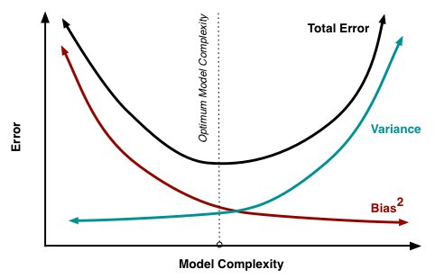

**Fig. 1** Bias and Variance contributing to total error

1. **Overfitting and Underfitting**

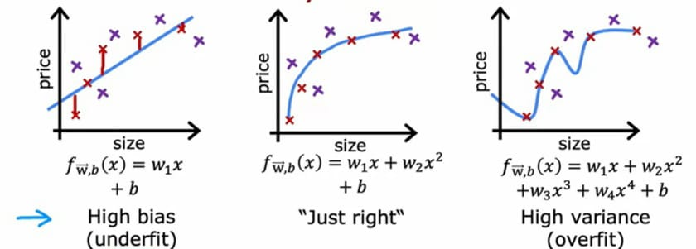

**Fig.1** Overfit and underfit graphical representation

**3.1 Underfitting in Machine Learning**

A statistical model or a machine learning algorithm is considered to exhibit underfitting when the model's simplicity is inadequate to capture the complexities present in the data. This insufficiency results in the model's inability to effectively learn from the training data, leading to subpar performance on both the training and testing datasets. In simpler terms, an underfit model produces inaccurate results, particularly when applied to new, previously unseen examples. Underfitting typically occurs when overly simplistic models with excessively simplified assumptions are employed. To address the issue of underfitting in a model, it is necessary to utilize more complex models, improve the representation of features, and reduce the degree of regularization applied to the model.

**Reasons for Underfitting:**

* The model is too simple, So it may be not capable to represent the complexities in the data.
* The input features which is used to train the model is not the adequate representations of underlying factors influencing the target variable.
* The size of the training dataset used is not enough.
* Excessive regularization are used to prevent the overfitting, which constraint the model to capture the data well.
* Features are not scaled.

**Techniques to Reduce Underfitting:**

* Increase model complexity.
* Increase the number of features, performing feature engineering.
* Remove noise from the data.
* Increase the number of epochs or increase the duration of training to get better results.

**3.2 Overfitting in Machine Learning**

Overfitting occurs in a statistical model when it fails to make accurate predictions on testing data. This situation arises when a model is trained with an excessive amount of data, causing it to learn not only from the genuine patterns but also from the noise and inaccuracies present in the dataset. Consequently, when this overfitted model is applied to test data, it exhibits a high level of variance, leading to inaccurate categorization of data due to an excessive focus on the dataset's intricate details and noise.

Overfitting is often associated with non-parametric and non-linear machine learning methods. These algorithms possess greater flexibility in constructing models based on the dataset, enabling them to create models that are overly complex and unrealistic.

To combat overfitting, it is advisable to consider using a linear algorithm when dealing with linear data. Alternatively, when working with decision trees, parameters like the maximum depth can be adjusted to control the model's complexity and mitigate the risk of overfitting.

**Reasons for Overfitting:**

* High variance and low bias.
* The model is too complex.
* The size of the training data.

**Techniques to Reduce Overfitting**

* Increase training data.
* Reduce model complexity.
* Early stopping during the training phase (have an eye over the loss over the training period as soon as loss begins to increase stop training).
* Ridge Regularization and Lasso Regularization.
* Use dropout for neural networks to tackle overfitting.

1. **Predictive Maintenance with Machine Learning**

**4.1. Dataset Selection:**

Selecting an appropriate dataset is crucial for illustrating the bias-variance trade-off. The dataset should be complex enough to demonstrate the concept but not excessively so to remain manageable for the case study.

**4.2 Model Selection:**

The choice of machine learning algorithm is pivotal. We must select an algorithm that aligns with the case study's objectives and the dataset's nature. The selected algorithm should allow for a spectrum of model complexities.

**4.3 Model Development:**

To explore the bias-variance trade-off, we need to split the dataset into training, validation, and test sets. The model should be trained with varying levels of complexity or hyperparameters, and relevant metrics, such as training error, validation error, and test error, must be recorded.

**4.3 Bias and Variance Analysis:**

We will employ visualizations and plots to illustrate the trade-off between bias and variance as the model's complexity changes. This section will offer a visual representation of the effects of different complexities on model performance.

**4.4 Results:**

The results section will present error metrics, model complexities, and observations related to bias and variance. This will demonstrate how the bias-variance trade-off affects model performance.

**Discussion:**

In the discussion, we will delve into the implications of the results, including the relationship between model complexity and bias-variance. We will explain how overfitting and underfitting were observed in the study and provide insights into making informed decisions when choosing model complexities.

1. **Conclusion**

In this comprehensive case study, we have explored the Bias-Variance Dilemma in machine learning through the lens of a predictive maintenance problem. We demonstrated the impact of bias and variance on model performance and provided insights into the associated costs and trade-offs. Our case study underscores the importance of finding the right balance between bias and variance to create models that excel in real-world applications.

1. **Future Directions**

The case study raises several avenues for future research and application:

* Exploring advanced regularization techniques and hyperparameter tuning to further optimize model performance.
* Investigating the use of more complex models with ensemble methods to find a better trade-off between bias and variance.
* Examining the role of explainable AI in predictive maintenance to gain insights into model predictions and improve decision-making.

The Bias-Variance Dilemma remains a critical aspect of machine learning, and understanding how to navigate it effectively is essential for building models that meet real-world demands. This case study serves

**References:**

[1]<https://zahidhasan.github.io/2020/10/13/bias-variance-trade-off-and-learning-curve.html>

[2] <https://www.geeksforgeeks.org/underfitting-and-overfitting-in-machine-learning/>

[3] Yu, L., Lai, K. K., Wang, S., & Huang, W. (2006). A Bias-Variance-Complexity Trade-Off Framework for Complex System Modeling. In M. Gavrilova et al. (Eds.), ICCSA 2006, LNCS 3980 (pp. 518-527). Springer-Verlag Berlin Heidelberg.

[4] K. Kadam, "Face recognition based on Bias-Variance method," in International Conference on Advances in Engineering & Technology – 2014 (ICAET-2014), pp. 54-56

[5] Berardi, Victor & Zhang, Peter. (2003). An empirical investigation of bias and variance in time series forecasting: Modeling considerations and error evaluation. IEEE transactions on neural networks / a publication of the IEEE Neural Networks Council. 14. 668-79. 10.1109/TNN.2003.810601.

[6] Yang, Zitong, et al. "Rethinking bias-variance trade-off for generalization of neural networks." International Conference on Machine Learning. PMLR, 2020.